Homework Exercise: The Mystery Cell
Task 1: Image Sourcing
Find a peer-reviewed scientific article online and select one microscopic image that includes a visible scale bar.
Article: Wickramasinghe, N. I., Corbin, B., Kanakarathna, D. Y., Pang, Y., Abeywickrama, C. S., & Wijesinghe, K. J. (2023). Bright NIR-Emitting Styryl Pyridinium Dyes with Large Stokes’ Shift for Sensing Applications. Biosensors, 13(8), 799.
Selected figure: Figure 5 – fluorescence microscopy images of Saccharomyces cerevisiae, Bacillus megaterium, and Escherichia coli stained with probe 1b (10 µM). The figure contains fluorescence, bright-field and merged panels and a 20 µm scale bar.
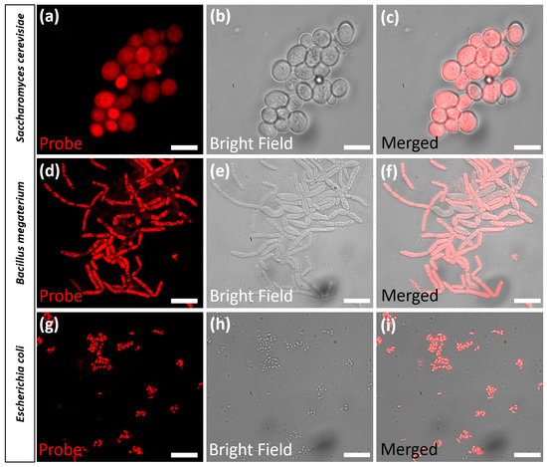
Open the original Figure 5: ResearchGate figure page | Publisher article (MDPI) | DOI

Task 2: Calculation
Using the scale bar as your reference, estimate the actual physical width of the primary cell or structure shown in the image. Show your calculation.
Selected structure: A representative E. coli cell in the fluorescence panel (g) of Figure 5.
Reference: The scale bar represents 20 µm.
Measurement estimate: The selected E. coli cell is about 3 µm long when compared with the 20 µm scale bar. This is an approximate value because the measurement is made from the published figure.
Parameter | Estimated value
Length of 20 µm scale bar | 20 µm
Apparent length of selected E. coli cell | ≈ 15% of the scale bar
Estimated cell length | 0.15 × 20 µm ≈ 3 µm
Calculation: Cell size ≈ (cell length ÷ scale-bar length) × scale-bar value
≈ 0.15 × 20 µm
≈ 3 µm
Interpretation: The value is reasonable for an E. coli cell. It should be treated as an estimate, not an exact measurement.

Task 3: Technique Identification
Write a short 3-sentence paragraph explaining whether the image was taken using Bright Field or Fluorescence microscopy, and justify your answer based on visual cues (background color, contrast, staining).
Answer – Fluorescence microscopy. The cells glow red against a dark background, which is a clear sign of fluorescence microscopy. The paper also says that the cells were excited with a 532 nm laser and observed using Cy3 filters.

Task 4: Quality Control
Identify one artifact in the image (if any) or describe what a potential preparation artifact might look like for this specific technique.
Potential artifact: Uneven background fluorescence or non-specific staining could be an artifact. It may look like red fluorescence outside the cells or bright areas that are not actually part of the cells.
Why it matters: Artifacts can make a cell look brighter or different from its real appearance. Possible problems include non-specific staining, dust, autofluorescence, out-of-focus light, and photobleaching. Controls are important to check that the fluorescence is real.
Specific observation in the selected figure: The authors report low background interference. So, instead of claiming that the figure definitely contains an artifact, we can describe the common artifact that should be checked for in this type of fluorescence image.

